NAME: SHOROUQ IQBAL

SECTION: BCS-1J

ROLL NO: 24K-0914

**Task 1:-**

#include<stdio.h>

int main()

{

float vi,acc,time,vf;

/* vi stands for initial velocity

vf stands for final velocity

acc stands for acceleration */

printf("Enter the initial Velocity:");

scanf("%f",&vi);

printf("\nEnter the acceleration:");

scanf("%f",&acc);

printf("\nEnter the time:");

scanf("%f",&time);

vf=vi +(acc*time);

printf("\nThe final velocity calculated is %f",vf);

return 0;

}

Output:-

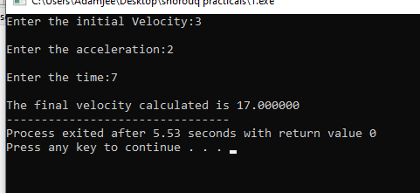

**Task 2:-**

#include<stdio.h>

int main()

{

float vi,acc,vf,time;

printf("Enter the initial Velocity:");

scanf("%f",&vi);

printf("\nEnter the final velocity:");

scanf("%f",&vf);

printf("\nEnter the time:");

scanf("%f",&time);

acc=(vf-vi)/time;

printf("The acceleration calculated is %f",acc);

return 0;

}

Output:

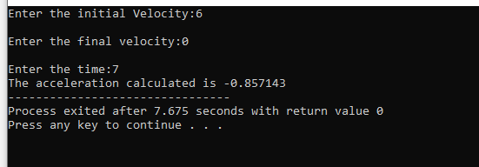

**Task 3:-**

#include<stdio.h>

int main()

{int salary,tax;

float rate;

printf("Enter the tax rate:");

scanf("%f",&rate);

printf("\nEnter the salary:");

scanf("%d",&salary);

tax=rate*salary;

printf("The tax calculated is %d",tax);

return 0;

}

Output: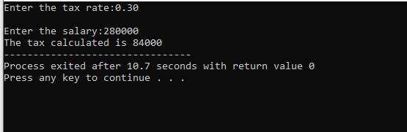

**Task 4:-**

#include<stdio.h>

int main()

{

int x1=4,x2=3,y1=4,y2=2;

float slope;

slope=(y2-y1)/(x2-x1);

printf("The slope calculated of two points is %.3f",slope);

return 0;

}

Output:- 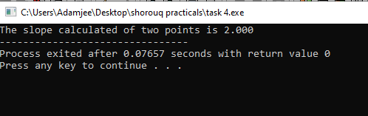

**Task 5:-**

#include<stdio.h>

#include<math.h>

int main()

{

float p,r,n;

float compound_interest;

printf("Enter the initial principle balance:");

scanf("%f",&p);

printf("\nEnter the interest rate:");

scanf("%f",&r);

printf("\nEnter the number of times interest applied:");

scanf("%f",&n);

compound_interest=p*pow(1+r/100,n)-p;

printf("The interest calculated is %f",compound_interest);

return 0;

}

Output:-

